Full Repetition

🔁 What is Identical Rhyme – Full Repetition
# Source: AI Source: Provided by: [Data Path: Persons Table -> ID Column: 1, Name_En Column: Motasem Essam] -> From: [Chatgpt (GPT-4-turbo)] on [8/2/2025]
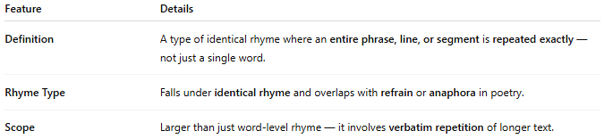
Feature | Details
Definition | A type of identical rhyme where an entire phrase, line, or segment is repeated exactly — not just a single word.
Rhyme Type | Falls under identical rhyme and overlaps with refrain or anaphora in poetry.
Scope | Larger than just word-level rhyme — it involves verbatim repetition of longer text.

📝 Examples:
# Source: AI Source: Provided by: [Data Path: Persons Table -> ID Column: 1, Name_En Column: Motasem Essam] -> From: [Chatgpt (GPT-4-turbo)] on [8/2/2025]
I walk alone beneath the sky,
I walk alone beneath the sky.
Nothing remains but the silence,
Nothing remains but the silence.

🎭 Effect in Poetry:
# Source: AI Source: Provided by: [Data Path: Persons Table -> ID Column: 1, Name_En Column: Motasem Essam] -> From: [Chatgpt (GPT-4-turbo)] on [8/2/2025]
- Adds emphasis, ritual, or emotional intensity
- Builds a rhythmic pattern through repetition
- Often used in lyrics, refrains, or choruses

🔗 Related Concepts:
# Source: AI Source: Provided by: [Data Path: Persons Table -> ID Column: 1, Name_En Column: Motasem Essam] -> From: [Chatgpt (GPT-4-turbo)] on [8/2/2025]
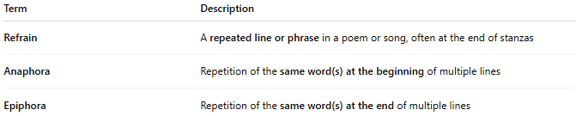
Term | Description
Refrain | A repeated line or phrase in a poem or song, often at the end of stanzas
Anaphora | Repetition of the same word(s) at the beginning of multiple lines
Epiphora | Repetition of the same word(s) at the end of multiple lines

✅ When to Use:
# Source: AI Source: Provided by: [Data Path: Persons Table -> ID Column: 1, Name_En Column: Motasem Essam] -> From: [Chatgpt (GPT-4-turbo)] on [8/2/2025]
- When you want to drive home a central message
- To create unity across stanzas or verses
- To add a chant-like or meditative effect

